Indonesia Invites Japan to Develop Electric Vehicle Ecosystem in ASEAN

Jakarta, 13 July 2023 - Indonesia has invited Japan to collaborate in developing the electric vehicle (EV) ecosystem in ASEAN. This statement was made by Foreign Minister Retno Marsudi during the ASEAN-Japan Post Ministerial Conference (PMC) in Jakarta on Thursday (13/7).

There are two areas of cooperation that need to be encouraged to establish the Indo-Pacific as a center of growth.

Firstly, the development of electric vehicles (EV) ecosystem in ASEAN countries.

"We have often discussed this matter. Now is the time to turn these plans into reality. ASEAN and Japan will both benefit from this collaboration," said Foreign Minister Retno.

Japan is currently transitioning to 100% electric vehicles by 2035 and aims to become a leader in the electric vehicle industry. ASEAN is the right partner for Japan in the development of electric vehicle batteries.

"Japan can support this cooperation, including through the Green Innovation Fund. The EV ecosystem will not only bring prosperity to the region but also bring us closer to a carbon-free society," said Foreign Minister Retno.

Secondly, cooperation in maintaining peace and stability in the region. Indonesia believes that Japan also desires a peaceful, stable, and prosperous Indo-Pacific region.

"We want an inclusive regional architecture where all countries can feel secure. Only then can we focus on making our region a center of growth," said Foreign Minister Retno.

The 50th anniversary of ASEAN-Japan relations this year serves as a momentum to strengthen cooperation. In the economic sector, the meeting welcomed the ASEAN Japan Economic Co-Creation Vision to promote various cooperation in the digital economy, innovative financing for infrastructure, green economy to support sustainable development, support for SMEs, and strengthening the global supply chain.

The meeting also emphasized the importance of identifying other strategic cooperation, including in the fields of energy transition, science and technology, cultural and tourism cooperation, and youth. In the sector of health, the meeting encouraged the implementation of the establishment of the ASEAN Centre for Public Health Emergencies and Emerging Diseases (ACPHEED). Japan is ready to support a more resilient ASEAN, including through the Asia Zero Emission Community (AZEC) initiative and quality infrastructure development.

In the security sector, the meeting highlighted the importance of maintaining stability and peace in the region through respect for international law and the principles of the UN Charter. The importance of cooperation in addressing non-traditional security issues such as cybersecurity was emphasized.

Japan is committed to continuing to support ASEAN centrality, including through the implementation of the ASEAN Outlook on the Indo-Pacific (AOIP). Japan has pledged a funding commitment of USD 100 million to support the implementation of the AOIP.

The meeting agreed to elevate the ASEAN-Japan partnership from Strategic Partnership to Comprehensive Strategic Partnership, which will be announced at the 26th ASEAN-Japan Summit in Jakarta in September. The Japanese Foreign Minister also invited ASEAN Leaders to attend the ASEAN-Japan Commemorative Summit in Tokyo on 16-18 December 2023, which will adopt the ASEAN-Japan Future Vision document.

***

For further information, please contact the following:

Director for Information and Media of the Ministry of Foreign Affairs - Hartyo Harkomoyo (+62811831899)

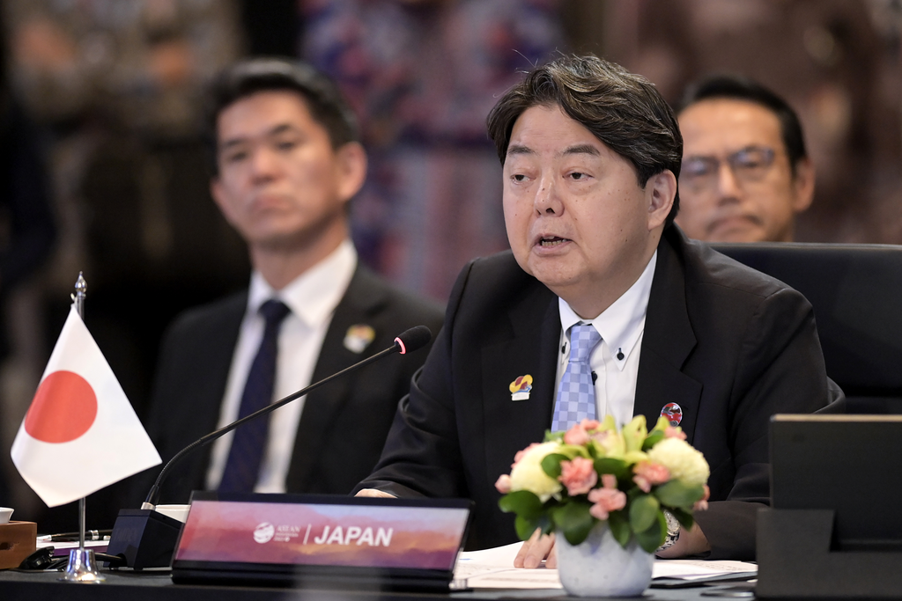

Indonesia has invited Japan to collaborate in developing the electric vehicle (EV) ecosystem in ASEAN during the ASEAN-Japan Post Ministerial Conference (PMC) in Jakarta on Thursday (13/7) (Photo: Ministry of Foreign Affairs of Indonesia).

